1.Create EFS file system.

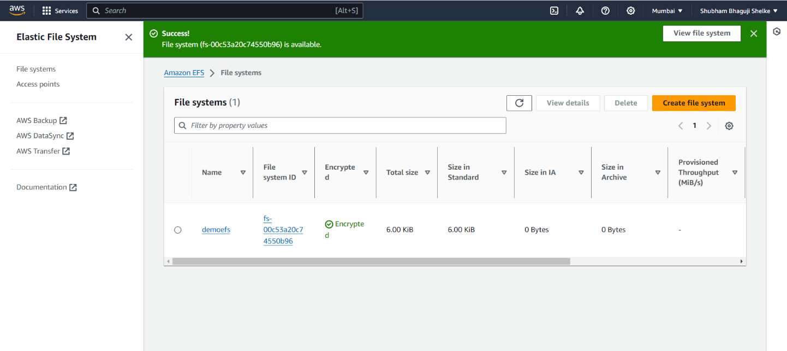

2.Create ec2 instance in ap-south-1a AZ

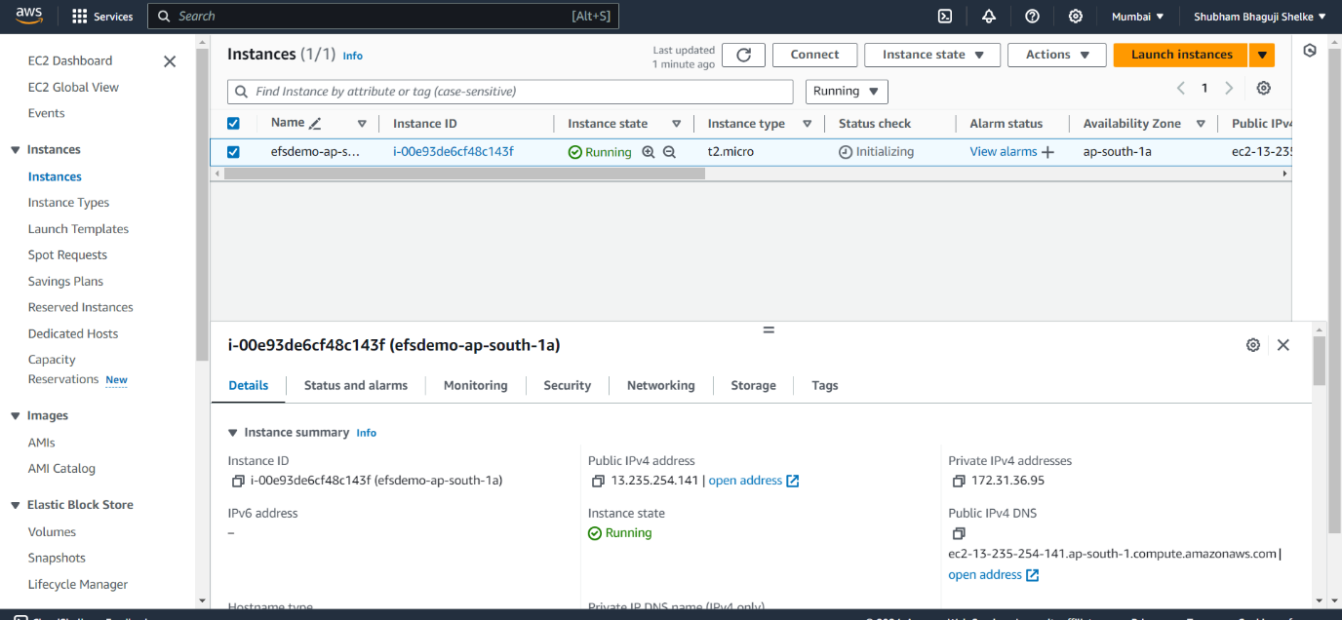

3.Create ec2 instance in ap-south-1b AZ

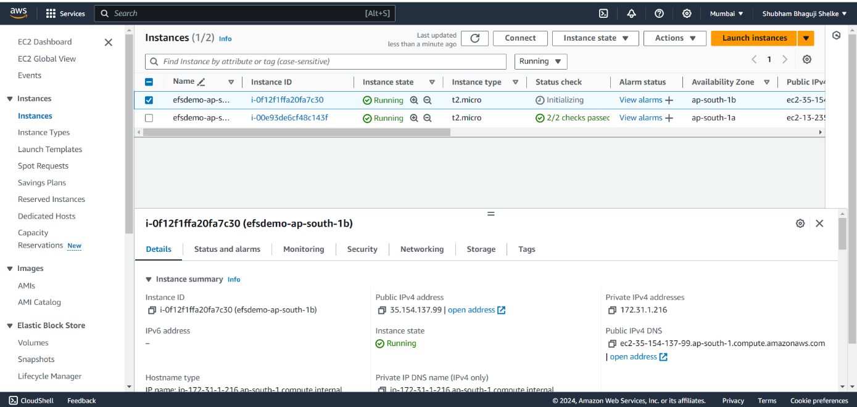

4.Mount SG on EFS Created file

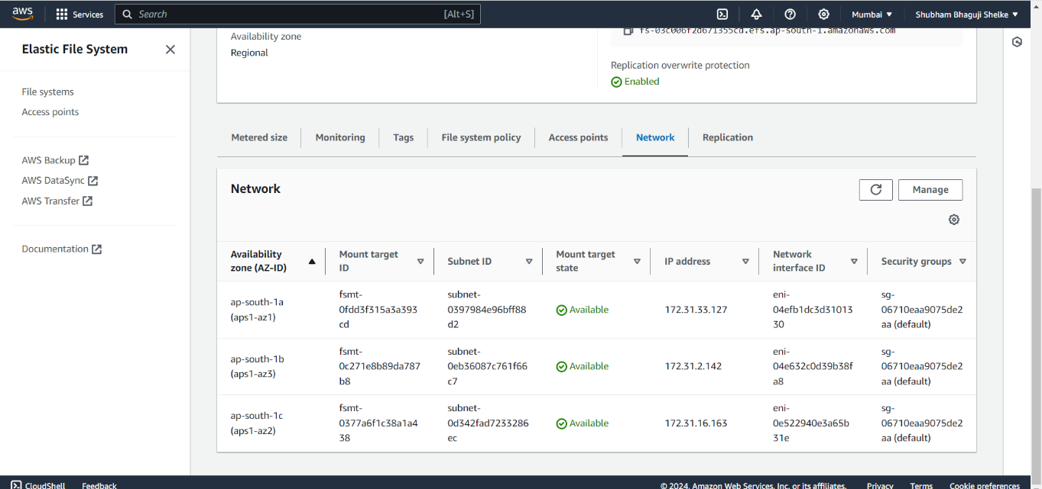

5. Ec2-user for ap-south-1a AZ

Create a one directory and mount a 1 file aws.txt

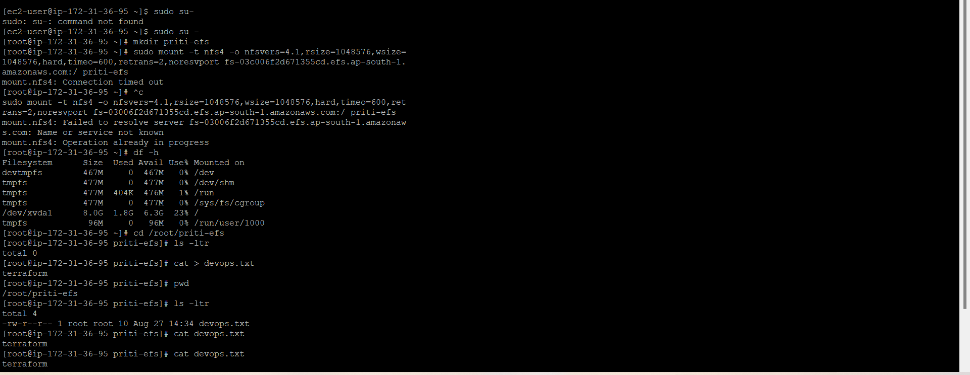

6.Ec2-user for ap-south-1a AZ

See aws.txt file which is created in AZ ap-south-1a

